**Design Document Group 3**

**180010031, 180010039, 170010023**

ER Model and DB Schema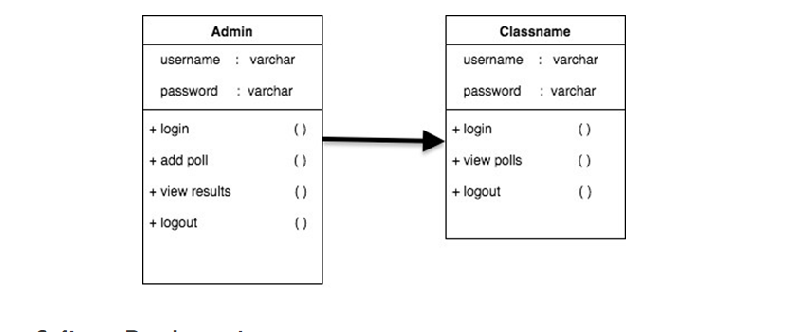

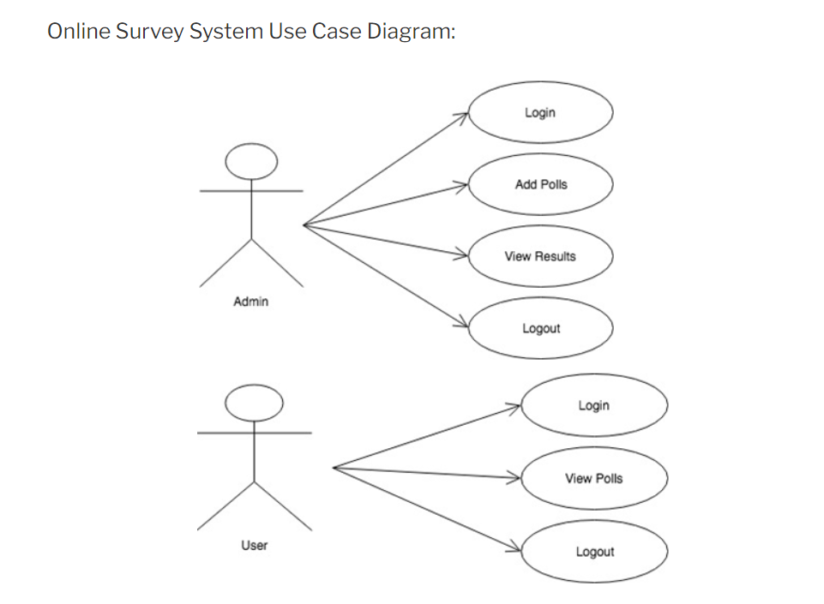

Admin Control Flow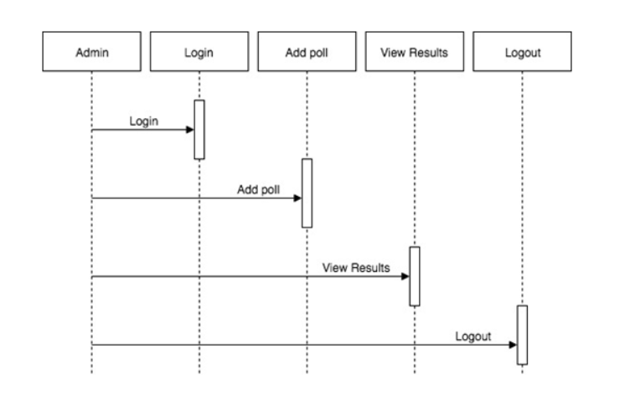

User Control Flow

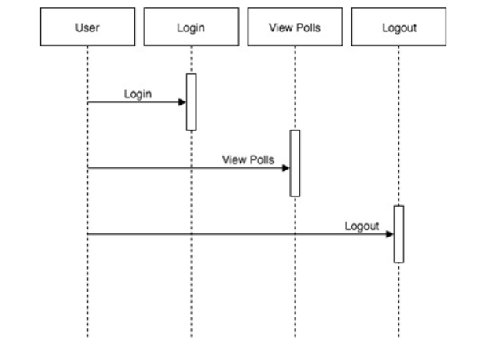

Screen Designs

We will implement a homepage which will have options for user/admin login .

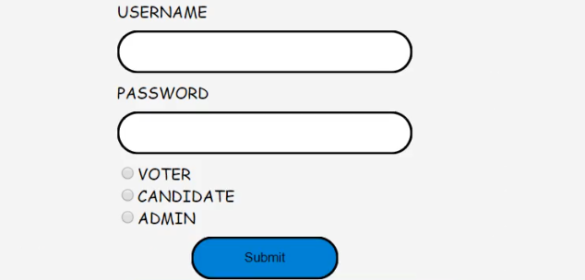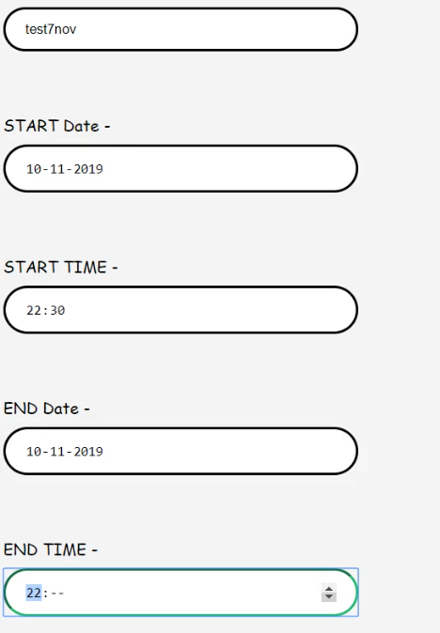

Sample Data Creation

We will provide a .sql file to create the tables and insert all the data

Admin can create surveys and users can vote in them only once

After the survey is completed, Admin can see the results of the survey